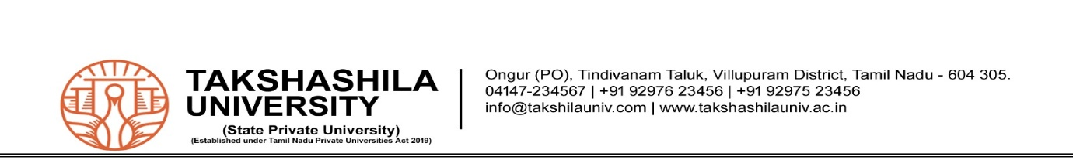
END SEMESTER- RESULT ANALYSIS: ACADEMIC YEAR - 2024-2025

Faculty : Faculty of Science Batch : 2024-2027
School : School of Computer Sciences Regulation : R-2024
Program : BCA Semester : I

Sl. No. | Course Code | Course Name | Name of the Staff | No. of Students Present | No. of Students Absent | No. of Students Passed | No. of Students Failed | Pass %
 | U24TAT171 | TAMIL-I | Mr.S.Santhoshkumar | 50 | - | 48 | 2 | 96%
 | U24ENT171 | ENGLISH-I | Ms.Kalaiselvi | 50 | - | 50 | - | 100%
 | U24CSB171 | PROBLEM SOLVING  USING C | Dr.T.Vijayakumar | 50 | - | 48 | 2 | 96%
 | U24CSB172 | DIGITAL LOGIC  FUNDAMENTALS | Mr.R.Bharathidasan | 50 | - | 50 | - | 100%
 | U24MAT171 | COMPUTATIONAL  MATHEMATICS | Dr.N.P.Damodaran | 50 | - | 43 | 07 | 86%
 | U24CAB161 | UI AND UX EXPERT | Mr.R.Prasanth | 50 | - | 35 | 18 | 70%

Total No. of Students Registered : 50 Pass Percentage :
60%
Number of students passed in all Courses : 30

Batch Co-ordinator School In-charge Dean


END-SEMESTER RESULT ANALYSIS ACADEMIC YEAR - 2024-2025

Faculty : Faculty of Sciences Batch : 2024-2027
School : School of Computer Sciences Regulation : R-2024
Program : BCA specialization with FSD Semester : II
Sl. No. | Course Code | Course Name | Name of the Staff | No. of Students Present | No. of Students Absent | No. of Students Passed | No. of Students Failed | Pass %
1 | U24TAT272 | Tamil-II | Mr.S.Santhoshkumar | 50 | Nil | 50 | Nil | 100%
2 | U24ENT272 | Communicative  English-II | Ms.P.Kalaiselvi | 50 | Nil | 48 | 02 | 96%
3 | U24CSB271 | Object Oriented Programming using C++ | Dr.T.Vijayakumar | 50 | Nil | 50 | Nil | 100%
4 | U24CSB272 | Data Structures | Mrs.R.Saranya | 50 | Nil | 37 | 13 | 74%
5 | U24MAT273 | Discrete Mathematics | Dr.N.P.Damodaran | 50 | Nil | 50 | Nil | 100%
6 | U24CAB262 | Backend Development | Mr.R.Prasanth | 50 | Nil | 42 | 8 | 84%
7 | U24CSP281 | Animation and Gaming-II | Mr.R.Bharathidasan | 50 | Nil | 50 | Nil | 100%
8 | U24UMP291 | Takshashila Innovative Learning-II | Mr.S.Balamurugan | 50 | Nil | 50 | Nil | 100%
9 | U24UMP292 | Yoga and Meditation-II | Mrs.Priyadharshini | 50 | Nil | 50 | Nil | 100%
10 | U24UMP293 | Green Credit – II | Mr.Suthakar | 50 | Nil | 50 | Nil | 100%

Total No. of Students Registered : 50 Pass Percentage : 66.67%
Number of students passed in all Courses : 33

Prepared by Checked by Verified by
Batch Co-ordinator School In-charge Dean-FSC

